Cyber Academy

Responsive web design

SUBMITTED BY

1. MUHAMMAD REBAAL (ID)

SUPERVISED BY

MUHAMMAD REBAAL

RESPONSIVE-WEBDESIGN REPORT SUBMITTED TO THE FACULTY OF Mr.Hammad, APTECH-GULSHAN-E-IQBAL.

2022

**Responsive-Design**

**Website**

**Batch – 2022**

APTECH, Gulshan-e-Iqbal, Karachi

December 2022

ACknowledgment

First of all, we thank Almighty Allah who praise us with the ability to think, work and deliver what we are assigned to do. Secondly, we must be grateful to our internal Mr. Hammad who help us in this project. We also acknowledge our teachers that throughout our studies helps us and guides us, departmental staff, university staff or other then this.

Introduction to Project creator

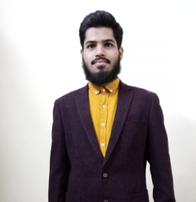

Muhammad Rebaal

Frontend-Developer, Js-Developer Student-1 Registration No.   
Immediate Contact: (mrebaal14@.com, +92-3192500809)

CERTIFICATE OF COMPLETION

**This is to certify that the following students of APTECH of batch 2022**

Muhammad Rebaal Student-1 Registration No.

**have successfully completed their final project titled**

Responsive web-design

**in the partial fulfillment of the Project of Responsive-Web-Design**

Muhammad Rebaal,

APTECH- Gulshan-e-Iqbal.

**INTRODUCION**

The website is about Cyber Academy, the total pages in this website are about 16 pages to provide services about various technologies revolving around the globe.

The project is concise of various technologies and being made by the supervision of the mentor Muhammad Rebaal. Furthermore, the whole web-design constituted of Bootstrap 5.0.It’s the simplest website you can access from anywhere.

**Table of Content**

(1)Home-Page:

(a)It includes the review of the influencers.

(2)About-Page:

(a)It includes the information about the company and the owner.

(3)Contact-Page:

(a)It includes the contact form through you can excess more about us.

(4)Services-Page:

(a)It includes the services regarding technology which the company is offering.

**Conclusion**

With the grace of Allah, I am (M.Rebaal) has efficiently done this Project because of our mentor Sir Hammad and with the help of knowledge provided by the Aptech

Institution of Gulshan-Center, Karachi.